**EXPERIMENT 9 – DATA WRANGLING  
SCREENSHOT OF CODE**

REYES, John Emmanuel A. December 2,2019

2ECE-B

PROBLEM 1:

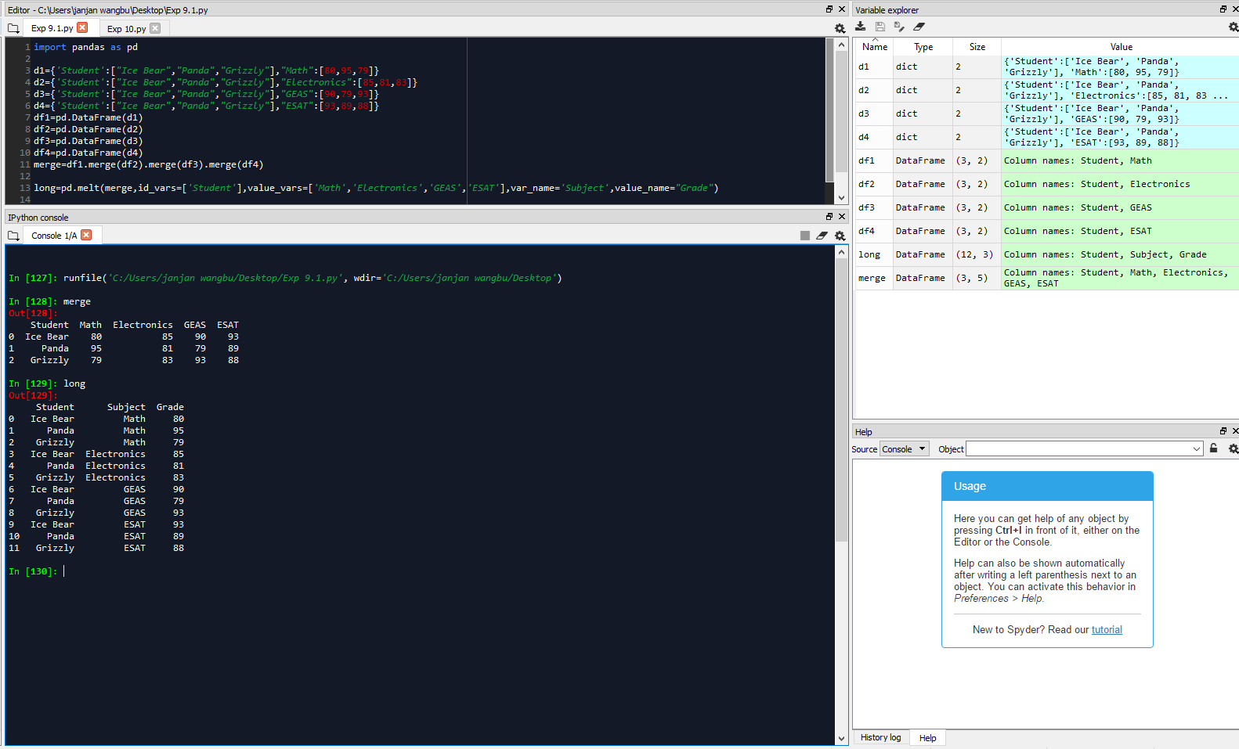

PROBLEM 2:

